Brochure

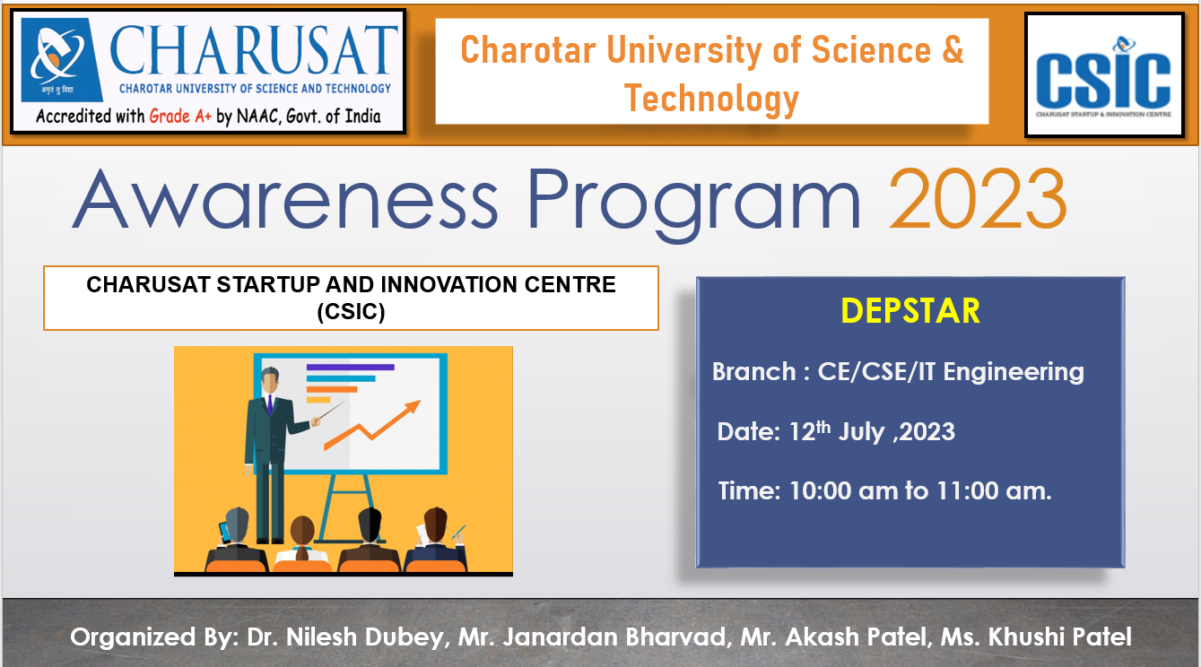

Summary of the

Awareness program Organized by DEPSTAR

Event Type: | Awareness Program
Title: | CSIC awareness program
Topic: | CSIC
Resource Person(s): (with designation, affiliation, email, phone number) | Dr. Nilesh Dubey  Assistant Professor,  Devang Patel Institute of Advance Technology and Research (DEPSTAR),  Charotar University of Science and Technology (CHARUSAT),  nileshdubey.ce@charusat.ac.in,  9726964512
Duration: | 01 hour
Funding from any Outside Agency: | SSIP
Targeted Audience: | 1st semester CE/CSE/IT
No. of Participants: | 156
Registration link | -
Organizers: (Team Members) | Dr. Jaimin N Undavia, Dr. Nilesh Dubey  Prof. Janardan bharvad, Prof. Akash Patel

“CSIC awareness program ”

12/07/2023

Report

Expert’s Name: - Dr. Nilesh Dubey

Brief Details of Workshop/Seminar/ program: -

To Provide awareness about start-up centre –CSIC (CHARUSAT STARTUP AND INNOVATION CENTRE). CSIC is a dynamic and forward-thinking start-up centre that focuses on Job Creators and not Job Seekers. To develop cutting-edge products/services that are designed to how it can address a specific problem or fulfil a need in the market. It works with a vision to develop successful entrepreneurs who can contribute (to nation building) through creativity, problem-solving and innovation for the growth and development of society at large. CSIC aims to create an entrepreneurial ecosystem within CHARUSAT that acts as a catalyst in identifying, motivating and nurturing entrepreneurial talents; mentoring them towards sustainable pursuits through entrepreneurship awareness, education, training and research. Some start-up has already gained significant traction in the industry. start-up and explore potential and opportunities with SSIP.

Glimpse of event:

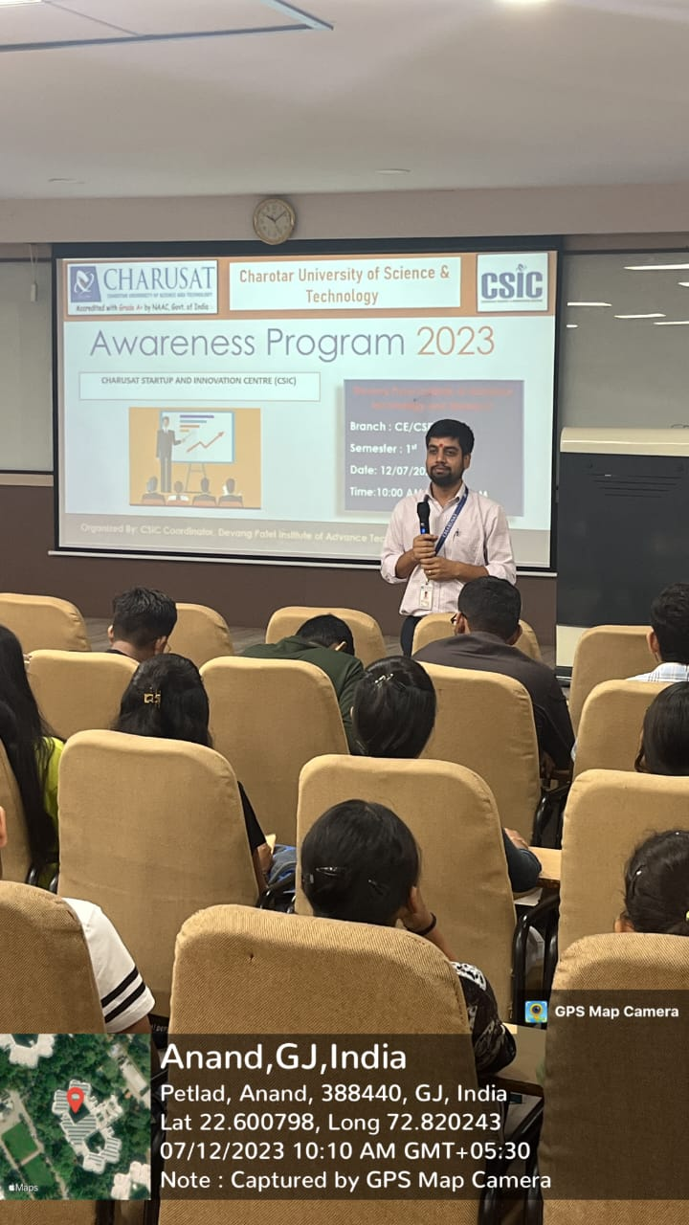 | 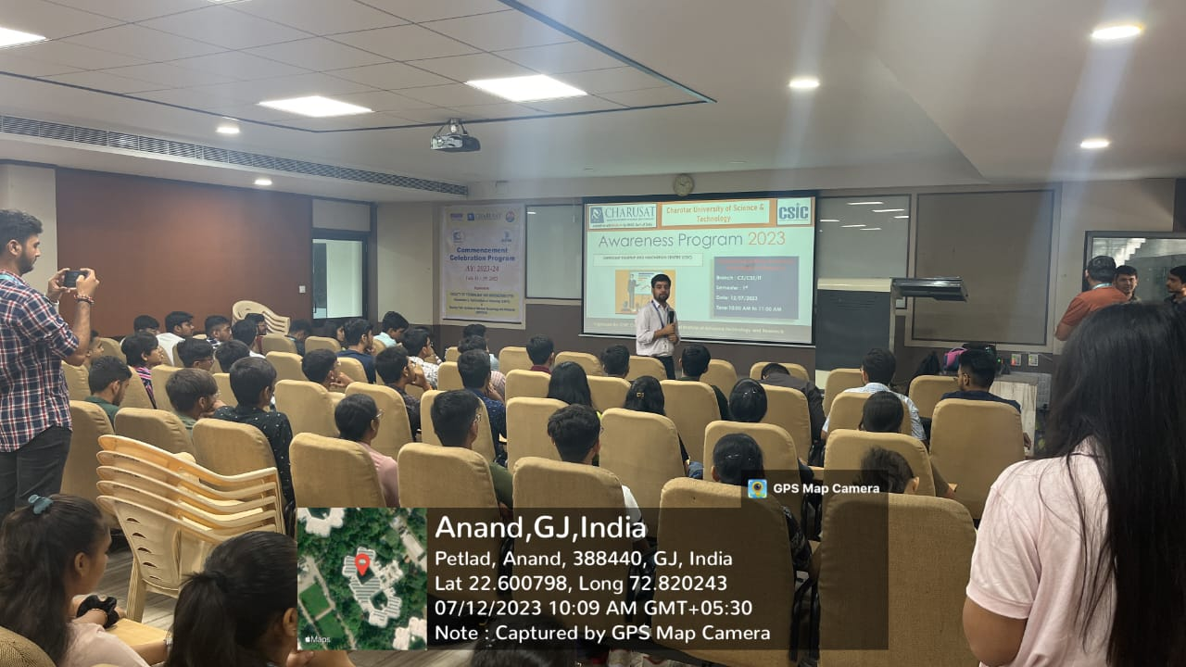
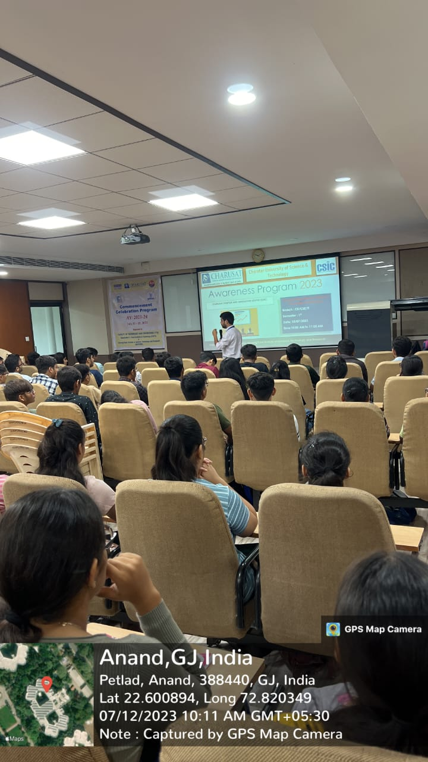 | 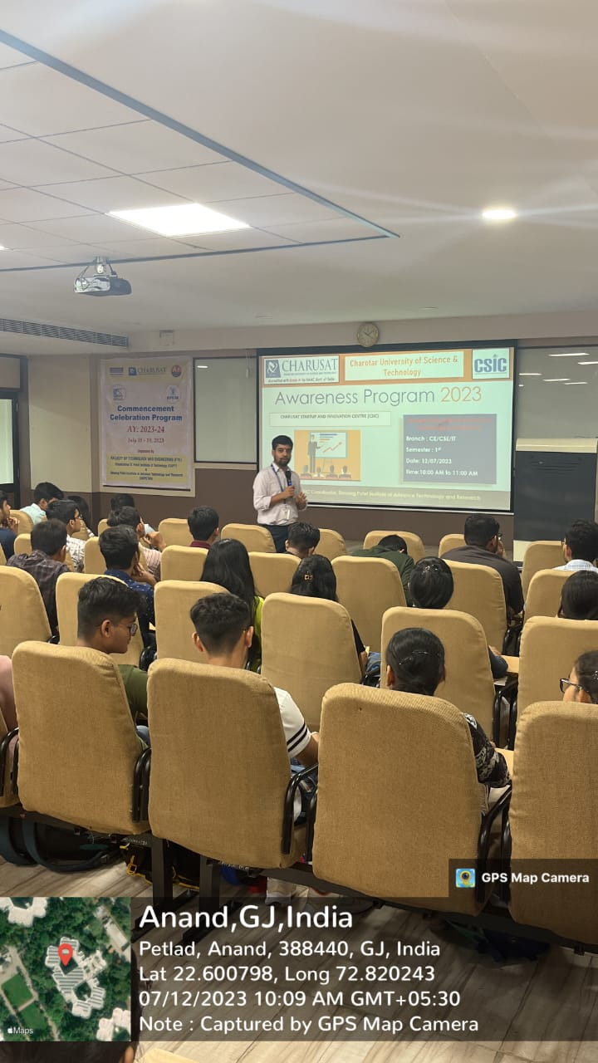
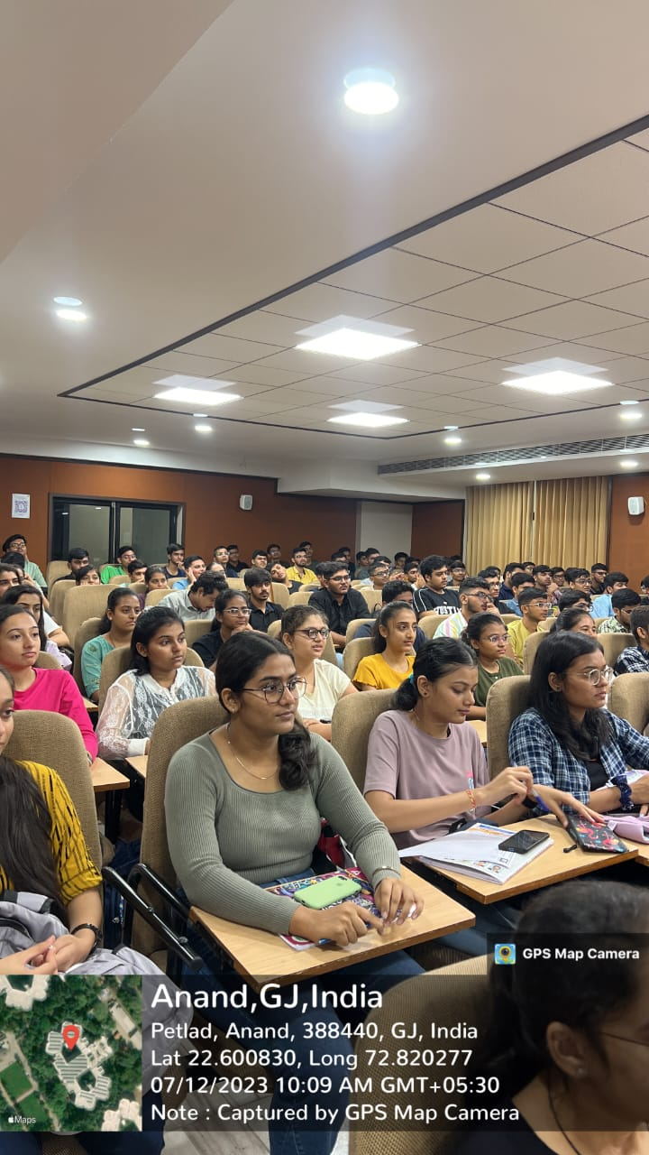 | 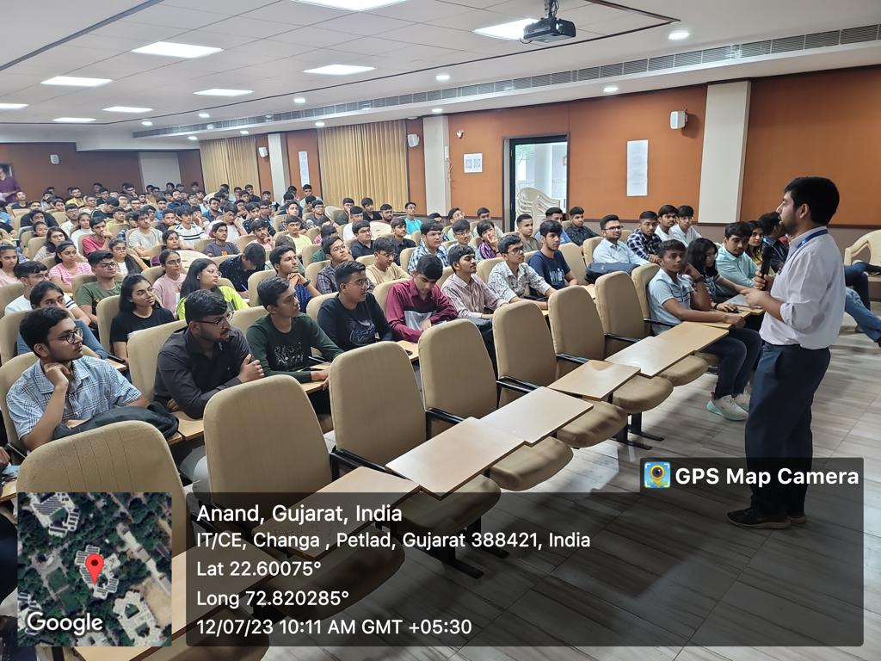

List of Present Students
